How to Access Program Review Reports
The public may access program review reports by clicking the reports button on the upper left of the system landing page (under Welcome) or by clicking a direct link: https://planning.lavc.edu/ProgramReview2/Home/Reports
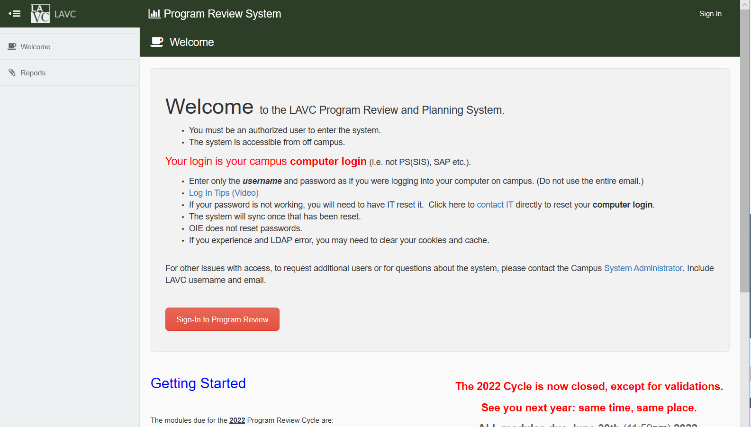
The reports menu will appear.
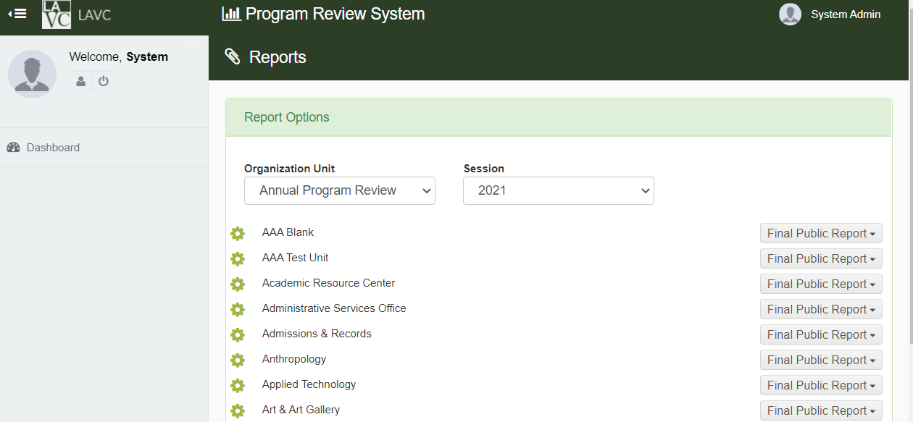
Select the program review cycle from the Session dropdown.

Find the unit you want to pull the report for, then Select Download or View report from the dropdown on the far right labeled Final Public Report.
The system will take a few minutes to generate the report. Please be patient.
A PDF document will appear for viewing or download.
