Using SharePoint for committee members
NOTE: USE IE for SharePoint sites

Logging into SharePoint
Go the link for the committee page (Ex: http://sharedgov.lavc.edu/sites/budgetcomm)
You will be prompted to enter your login credentials. Use your LAVC user login name and password to gain access to the SharePoint site.
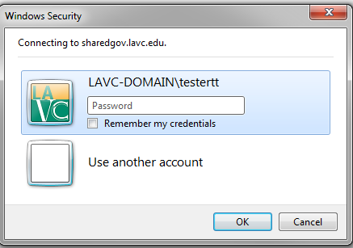

Landing page
Once inside the site you will see the landing page. The landing page will have a list of the most recently updated documents. You can access these documents or navigate to a specific document library to view documents not posted on the landing page.
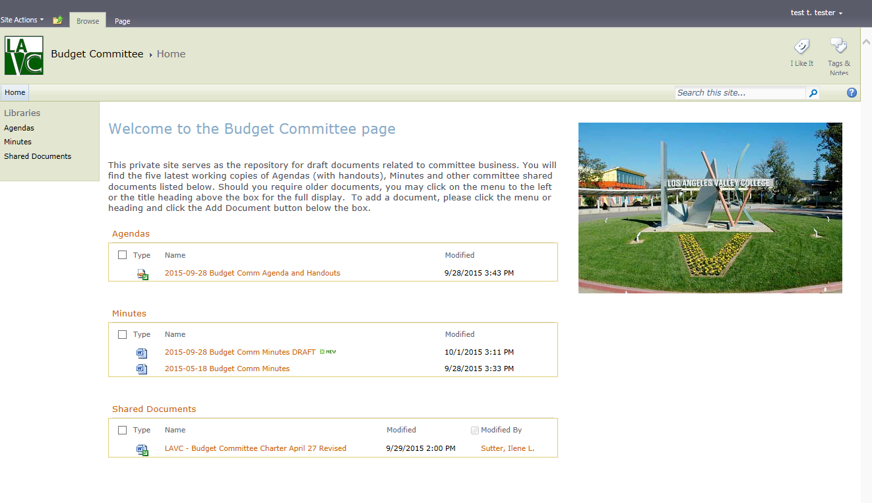

Document Libraries
All committee websites will have the following three document libraries.
- Agendas
- Minutes
- Shared Documents
The following table explains your access rights to the Document libraries mentioned above.
 | Can download/view documents | Can edit existing documents | Can upload documents
Agendas | X | X
Minutes | X | X
Shared Documents | X | X | X

Download documents for viewing
To view a document hover over the document name with your mouse so a check box appears. Click on the check box.
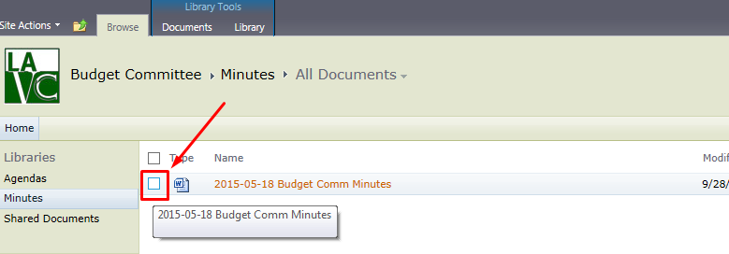
Once the check box is clicked the documents ribbon will appear. Click on the icon that says “Download a Copy”.
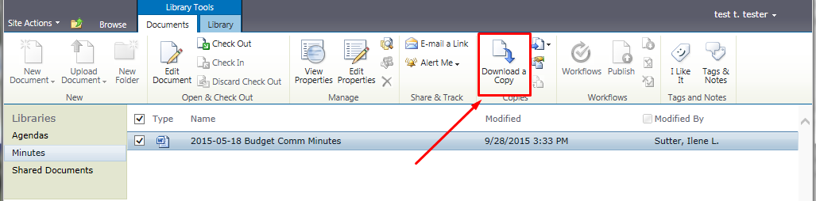
After clicking the “Download a Copy” icon you will get a prompt to save the document to your desktop. Click on the “Save” button

Editing a document
To edit a document navigate to the document library that has the document. In the list of documents double click on the document name.
Click the “Check out and Edit” radio button and then click the “OK” button. NOTE: While you have the document checked out no one else will be able to make updates. Also your updates will not be visible to other site members until you check the document back in.
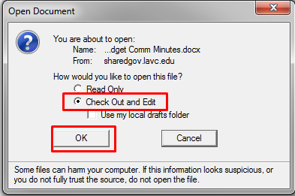
Before the document opens you will be promoted to enter your login credentials. 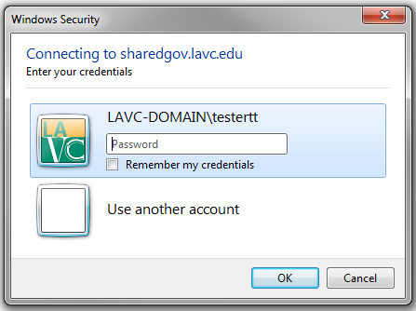
The document will open and you will be able to make edits. Make sure to save the changes to the document before closing the document.
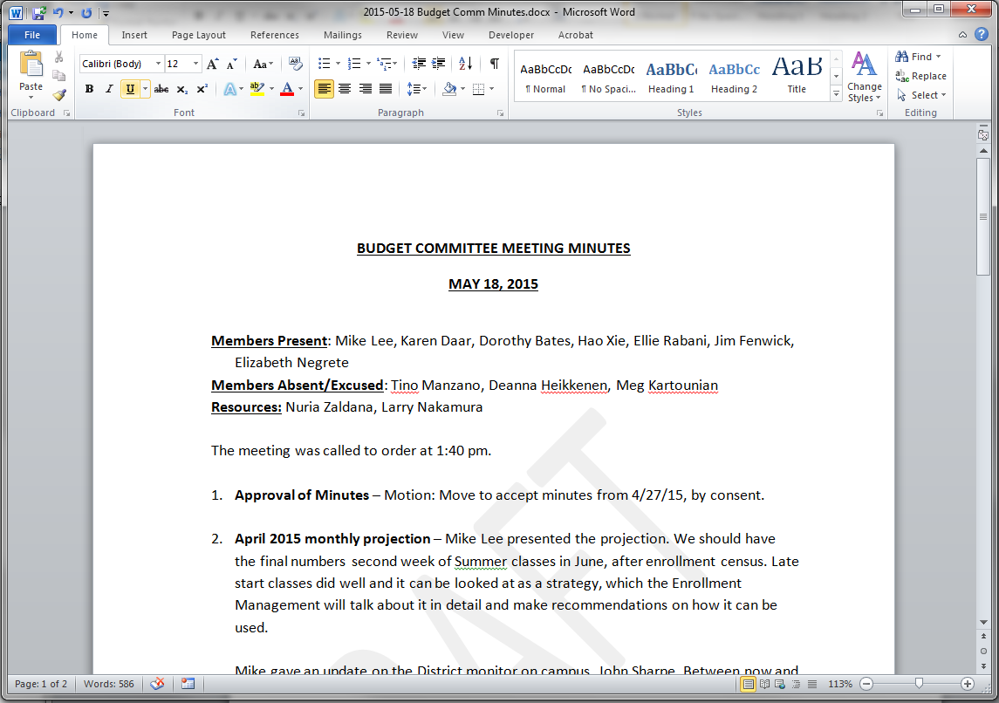
When you close your document once your edits are done you will be prompted with the following dialogue box. Make sure the click “Yes” to check in the file so others can see your updates and also make edits.

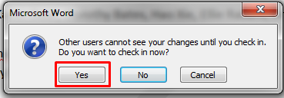
You will be presented with one more dialogue box to add version comments. Make sure to add a descriptive comment on the changes that were made and click the “OK” button.
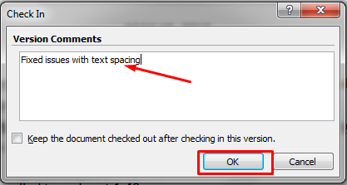

Undo a checkout
If you have accidentally checkout a document you can discard the checkout.
Hover over the document that has been checked out and click on the down arrow that appears to the right of the document name. Click on “Discard Check Out” option.
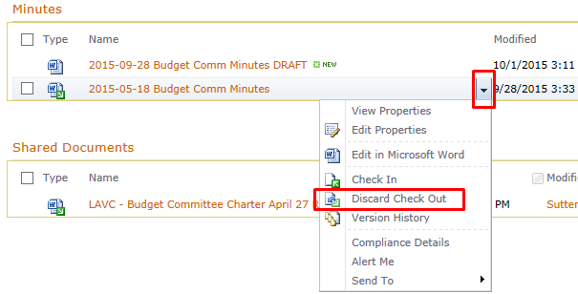
You will get a confirmation dialogue box. Click the “OK” button. The file is now no longer checked out.
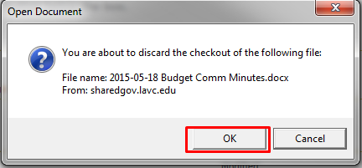

Who has a file checked out?
A file icon with a green arrow pointing down denotes that a file is check out. To see who has checked out the file hover over the file icon with your mouse and a tool tip with the information will appear.
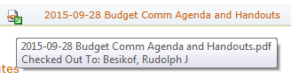

Uploading files to the Shared Documents library
As a committee member the only document library that you have upload rights is the Shared Documents library.
First navigate to the library by clicking on its name in the quick links located on the left of the SharePoint committee site.
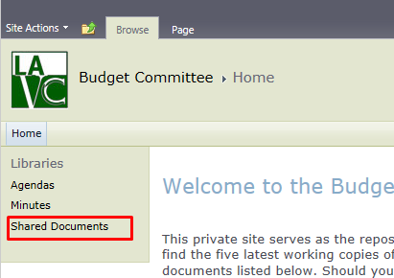
Click on the “Documents” tab at the top of the page
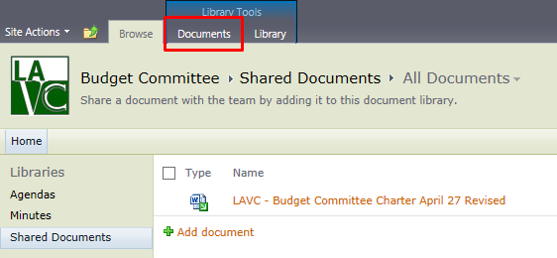
In the “Documents” ribbon click on the “Upload Document” down arrow to select the option between uploading a single document or uploading multiple documents. Use the dialogue boxes that appear to select the files for uploading.
